**Smart IoT Embedded Automated Medicine Dispenser**

Madhuri Sahu Shreyas Vilas Ekharkar Chetan Shrihari Awari Akashprasad Suryadevprasad

Yadav

[madhuridec9@](mailto:madhuridec9@) shreyas.ekharkar.cyb chetan.awari.cyb akashprasad.yadav.cyb

gmail.com @ghrce.raisoni.net @ghrce.raisoni.net @ghrce.raisoni.net

*Center Of Excellence G. H. Raisoni College G. H. Raisoni College G. H. Raisoni College of*

*(Artificial intelligence of Engineering, of Engineering, of Engineering,*

*and Machine Learning) Nagpur Nagpur Nagpur*

***Abstract-* The healthcare industry encounters difficulties in patient management due to a shortage of personnel. As reported by the World Health Organization (WHO), there is an average of 3 nurses for every 1,000 patients worldwide, a number that drops to 1.96 in nations such as India. A considerable number of chronic patients, frequently older or unable to move, need prompt medication, which leads to diminished efficiency and increased mental and physical stress on nursing staff. Current medication management systems are deficient in real-time data processing, emergency response features, and predictive notifications for refills, which worsens these issues. To tackle these shortcomings, a proposed automated medicine dispensing system utilizing the Internet of Things (IoT) is presented. This system employs QR codes to log patient information, allocate devices to specific beds, and organize medication schedules with alerts for any missed doses. It connects with a Firebase real-time database, allowing for continuous monitoring and high-alert functions, which include audio-visual alarms for emergencies and mobile notifications through a dedicated app. The application also keeps track of medication refill timelines based on patient discharge dates recorded in the database. This solution decreases the chances of accidental overdoses and underdoses by up to 98% and achieves 96% accuracy in medication alert notifications. By reducing workload and enhancing communication, resource efficiency is improved and nurse welfare, both mentally and physically, is supported. The proposed system signifies a major advancement in IoT-enabled healthcare, enhancing both medication management and the quality of patient care.**

**Keywords: *Automated Medicine Dispenser, Emergency Alert System, Firebase Database, Internet of Things (IoT), Real-time Monitoring.***

# **Introduction**

Healthcare has always focused on the needs of patients, and modern challenges are being effectively tackled with the help of the Internet of Things (IoT). IoT represents a transformative technology that is driving the fourth industrial revolution, resulting in significant improvements in connectivity, automation, and efficiency across a range of industries. Historically, prior to the emergence of advanced technologies, medication adherence management was performed manually, leading to many difficulties, especially for patients with serious chronic health issues. Errors such as incorrect dosage sequences, forgetting to take medications, or confusing different drugs often caused serious health consequences. Research by Singh et al. indicates that around 25% of elderly patients do not adhere to their prescribed medication regimens as instructed. A study conducted by professors Mahoney, Grey, and Blough at the University of Washington examined medication compliance among older individuals residing in three healthcare facilities. Involving 147 older adults on multiple medications, the results showed that just 30.6% of the participants correctly followed their prescribed medication schedules, while 18.4% were over-adhering to at least one medication. Traditional methods of dispensing and monitoring medications primarily relied on manual techniques, which made them susceptible to substantial errors.

In today's context, the healthcare industry continues to face challenges stemming from patients not adhering to their medication schedules. This issue is particularly crucial for individuals dealing with chronic health conditions such as diabetes, hypertension, heart-related diseases, or those confined to bed or with limited mobility. Failing to take prescribed medications on time can lead to declining health, more hospital admissions, and increased healthcare costs. Studies indicate that almost half of patients dealing with chronic illnesses have difficulty following their prescribed medication regimens, which exacerbates their health issues and increases the strain on healthcare systems [6].

To address these challenges, the healthcare sector has embraced cutting-edge technologies rooted in the Internet of Things (IoT) and automation. A prominent innovation is the IoT-enabled automated medicine dispenser. This device utilizes smart technology to automatically provide medications, guaranteeing that patients receive the right dosage at the correct times. Successful implementation relies on the fusion of both software and hardware technologies. The dispenser organizes medication schedules, links with mobile applications or cloud-based services, and reduces errors, thereby improving patient health outcomes.

The key elements of the automated medicine dispenser consist of a storage compartment, a dispensing mechanism, an IoT-enabled controller, and a display for reminders. The device can store a variety of medications, dispense them as per the prescribed schedules, and send notifications when it is time for medication. It also connects with systems used by physicians or caregivers, offering real-time updates on patient adherence.

The most notable advantage of the IoT-driven automated medicine dispenser is its ability to reduce human error, offering a reliable solution for patients who have difficulty remembering medication schedules or taking the right doses. This system ensures timely medication intake, boosts health outcomes, and sends reminders through mobile applications to aid in following treatment plans. Additionally, it promotes independence for patients, especially older adults and those with complex medication regimens, by streamlining medication management without the need for constant caregiver assistance.

The dispenser's efficiency is further enhanced by IoT capabilities, enabling remote monitoring and immediate communication between the device, patients, and healthcare providers. A notification system has been implemented to send alerts directly to personal digital assistants or smartphones. For example, if a patient misses a dose or encounters an issue, the dispenser informs caregivers. The connectivity facilitated by IoT improves healthcare management and reduces the necessity for hospital visits. We believe that employing software engineering practices throughout all phases of development is crucial for boosting the reliability of these systems and fostering greater trust among users.

***Novelty and Uniqueness of the Approach****:*

1. Hand detection technology for medication dispensing.

2. Emergency SOS notifications sent to nurses via app alerts.

3. Visual and auditory signals for prompt reminders.

4. Integration with a Firebase-based database.

# **LITERATURE REVIEW**

# The goal of this literature review is to assess previous research on medication management systems and cloud-based automated dispensers. With the rise of mobile applications and advancements in cloud technology, the integration of these innovations in the healthcare field holds considerable promise. Cloud-based systems improve dependability, reduce the likelihood of human error, and streamline procedures, resulting in more accurate and efficient healthcare outcomes.

# ***Scope of Review:***

# This review focuses on three main aspects:

# 1. The impact of automated dispensers on enhancing patient adherence.

# 2. The effect of cloud solutions on real-time patient tracking and management.

# 3. The contribution of technology to minimizing human errors and enhancing healthcare results.

# **Methodology**

***System Overview***

When a patient is admitted to the hospital for a stay longer than one day, they are assigned an Automated Medicine Dispenser (AMD). Each unit shows a QR code on its display that authorized staff members (such as physicians or nurses) can scan using a mobile application. After the code is scanned, the patient registration is completed with all required information, and the device is configured with details such as the patient number, bed number, and the machine's identification number. Additionally, the names of the medications and their schedules for dispensing are programmed into the device, enabling pill names to beAt the specified times, the authorized personnel remove the back panel of the device and fill it with a day’s worth of medication according to the established schedule. This data is transmitted to Firebase for patient record management, and the machine retrieves information using an ESP32 Wi-Fi module. The ESP32 can both send and receive data from the server whenever it connects to the internet. When the scheduled time arrives, the ESP issues a "start dispensing" command to the Arduino, which triggers visual and audible notifications through the display, LED, and buzzer.].

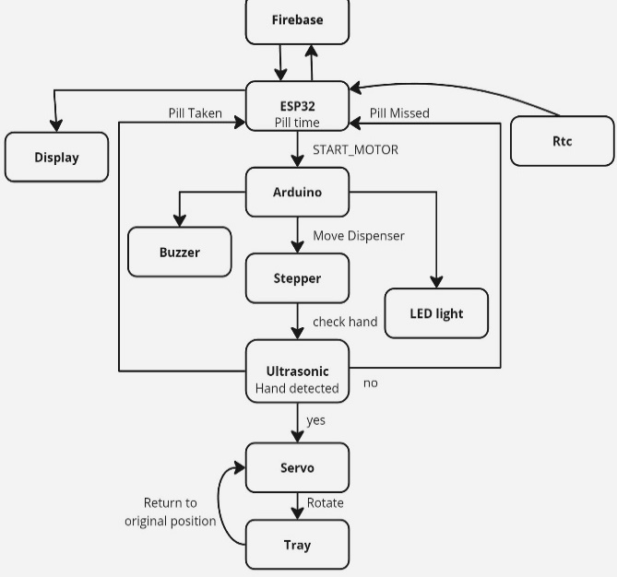

Figure 1: Hardware Workflow

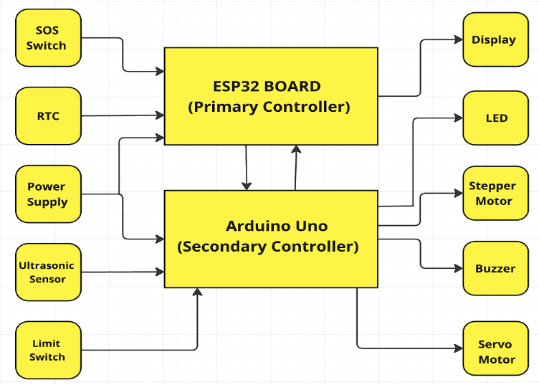***Dispensing System***

Inside the device, a stepper motor connected to a dispenser with segmented sections rotates 22.5 degrees to drop the pill into a tray. The tray, located immediately beneath the pill drop area, collects the dispensed pill. Afterward, the Arduino sends a "dispensing complete" notification to the ESP32. The LED and buzzer signals continue until an ultrasonic sensor detects a hand underneath the dispensing mechanism.

Once the ultrasonic sensor recognizes a hand, it relays a signal to the Arduino. The tray, which is connected to a servo motor, rotates 180 degrees, allowing the pill to fall through an opening in the underside. After a duration of 3 seconds, the tray moves back to its initial position.

***Missed Dose Procedure***

* In the event that a dose is overlooked:
* After 2 minutes, all alerts will reset and persist for 1 minute.
* This process will be repeated two times.
* If the medication is not taken by the subsequent dosing time, two pills will be provided.
* The name of the missed dose will be shown to confirm its accurate identification.
* This procedure lasts for 24 hours for each pill drop.

For each missed dose, a notification will be sent to authorized personnel stating, "Patient number: xxx and Bed number: xx missed dose of xx: xx am/pm" (where x represents numbers). If the SOS button is pressed, a high-priority alert is triggered, and both notifications will activate.

***Daily Procedures***

At the start of each day, the ward staff receives notifications indicating which machines need restocking and which ones should be collected, based on data stored in the Firebase database. The machines are then either replenished according to the prescriptions available in the app or picked up. For patients whose stays extend beyond their initial timeframe, only an authorized person can modify the allotted time for the machine.

***Hardware Description***

The ESP32 functions as the main microcontroller in this arrangement, managing all communication tasks, including Wi-Fi connectivity and high-level logic operations. It acts as the core controller, working alongside the Arduino Uno to handle sensors and motors. After establishing an internet connection, it interacts with the Firebase database to fetch scheduled pill dispensing times for particular patients. At the designated times, it sends commands. to dispense pills and displays relevant messages.

Figure 2: Block Diagram

The ESP32 sends data to Firebase regarding missed medications and emergency situations. For the connection setup, the TX pin of the ESP32 (GPIO17) connects to the RX pin of the Arduino (Pin 0), while the RX pin of the ESP32 (GPIO16) is linked to the TX pin of the Arduino (Pin 1). To ensure a proper power supply, an IC 7805 is used to regulate the operating voltage of the ESP32, with the positive terminal connected to 5V and the negative terminal linked to a common ground.

The Arduino Uno acts as the secondary microcontroller, handling hardware-specific tasks such as controlling the stepper motor, processing sensor information, and managing real-time schedules. It interacts with the ESP32 via either UART (serial) or I2C protocol. This connection with the ESP32 facilitates the management of medicine dispensing and communication regarding the dispensed pills and their collection status. The Arduino receives power directly from a charger that converts AC to DC, outputting a voltage of 5V.

The system includes a high-resolution display that can clearly show QR codes, with dimensions of 128px x 160px. Connected to the communication microcontroller, the display indicates the names of the pills being dispensed. In case doses are missed, it shows appropriate messages alongside the medicine names, helping users recognize both current and missed medications, particularly when several pills are dispensed simultaneously. The display gets its power from the ESP32 microcontroller and is connected to the necessary ESP32 pins for it to function correctly.

A stepper motor, attached to the rotating disk of the dispensing mechanism, is controlled by the main microcontroller. With programmed capabilities, it accurately rotates 22.5 degrees to align with the 16 compartments on the disk. Each rotation permits pills from the compartments to fall into the collection tray. The motor is powered by the battery via a IC7805 voltage regulator to sustain a 5V operating voltage, and its ground is linked to a common ground. A ULN2003 connector facilitates the connection of the stepper motor to the Arduino, with connections for 1NF, 2NF, 3NF, and 4NF wired to digital pins 8, 9, 10, and 11 accordingly.

The servo motor system manages the pill collection tray and works in conjunction with the ultrasonic sensor. When the sensor detects a hand, it directs the secondary controller to dispense the pill from the tray, prompting the servo motor to rotate 180 degrees and then return to its starting position after 3 seconds. Power comes from the IC7805’s 5V output, with the signal wire linked to the Arduino’s digital pin 5 and the ground attached to the common ground.

To improve security and functionality, the system incorporates several switches. A limit switch monitors compartment access, generating notification alerts whenever the compartments are opened, which enhances the system's security by recording all access events. This switch connects to the D2 pin on the Arduino using a common ground. Furthermore, an SOS switch connected to the primary microcontroller (ESP32 GPIO23) enables emergency alerts when activated.

The RTC module ensures accurate timing synchronization, enabling the medicine dispenser to follow precise schedules for dispensing medications and sending reminders, and monitoring missed doses. It operates on 5V sourced from the ESP32, with SDA and SCL connections made to the ESP32's GPIO21 and GPIO22 pins, respectively.

Visual and sound notifications are handled via LED and buzzer components operated by the secondary controller. These notifications activate for one minute until hand detection is registered during medication dispensing times, and they recur for any doses that are missed. In emergencies that trigger the SOS, the alerts are characterized by distinct patterns: the standard operation utilizes a frequency of 500Hz with 500-millisecond intervals, whereas emergency scenarios employ a frequency of 1kHz with 100-millisecond intervals.

The buzzer is connected to pin D13 of the Arduino, while the LED is linked to pin D12 through 220-ohm resistors. The ultrasonic sensor collaborates with the secondary controller to identify hand presence, effectively preventing medication from being dispensed without a direct hand interaction. It receives power directly from the Arduino’s 5V supply, with the trigger and echo pins connected to D7 and D6, respectively. The power supply configuration is intended to support various IoT devices through a system of 12V rechargeable lithium-ion batteries. Components such as the ESP32, stepper motor, and servo motor are connected to the battery through voltage regulators IC7805, while the Arduino is powered using an AC-DC converter. This setup, which incorporates lithium-ion batteries along with three step-down voltage regulators, ensures the dependable and precise functioning of the medicine dispensing system.

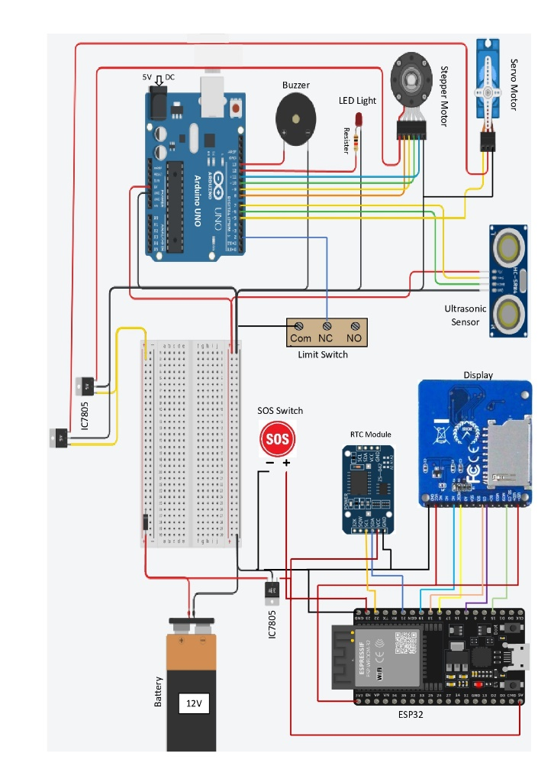

Figure 3: Circuit diagram

***Software Description***

The software for the system is created using the Arduino IDE, which is used to program the microcontrollers and manage the behaviour of various components. This is essential for basic operations such as generating and showing QR codes, sending alerts for missed doses, and displaying the names of medications that correspond to the currently active compartment. To facilitate smooth functionality, the system includes features for controlling LEDs and buzzers, thereby notifying users when it’s time to take their medication or in emergency situations. The stepper motors are carefully regulated to rotate the compartments, and limit switches are continuously monitored to ensure safe and reliable operation.

For the mobile app, Android Studio is utilized along with Kotlin and XML, which serve as the foundational framework of the application. The app offers a user-friendly interface that simplifies system management. It includes features like QR code scanning, which helps connect AMD devices to specific patients and beds. Furthermore, the app allows for the setting and adjustment of admission durations, making it simple to modify for longer stays when necessary. Medication scheduling, device management, and notifications are seamlessly integrated, with real-time synchronization via the Firebase Realtime Database to keep information up to date***.***

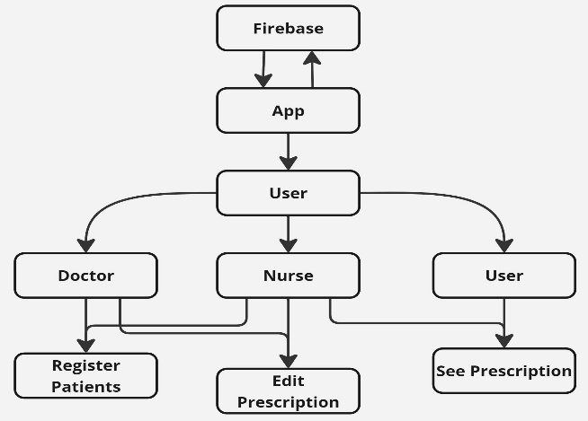

Figure 4: Mobile App Authorization

This software solution seeks to be both accurate and user-friendly, while maintaining high security standards. By combing sophisticated programming techniques with a user-friendly mobile app, the system provides a reliable and efficient method for managing medications and patient care.

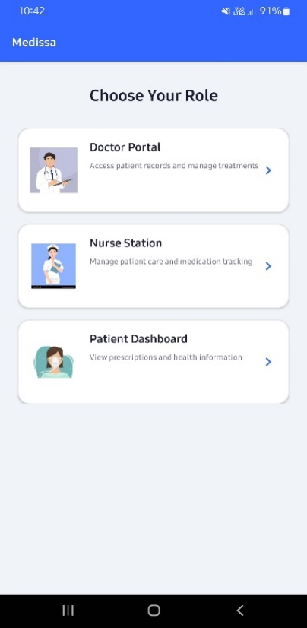

Figure 5: User Type Interface

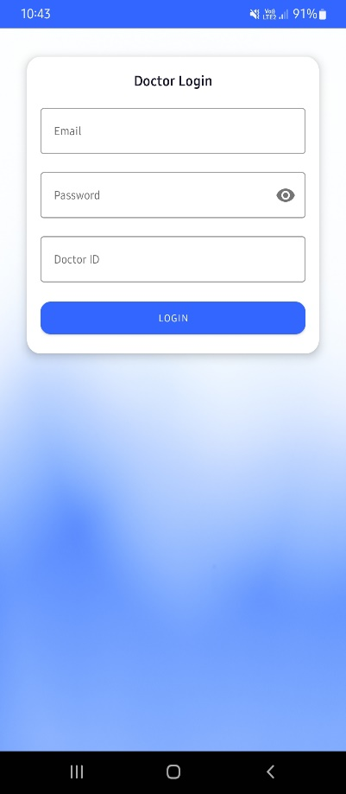

Figure 6: Doctor Login Interface

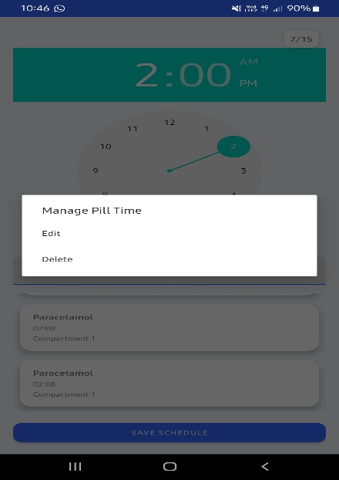

Figure 7: Schedule Edit/Delete Interface

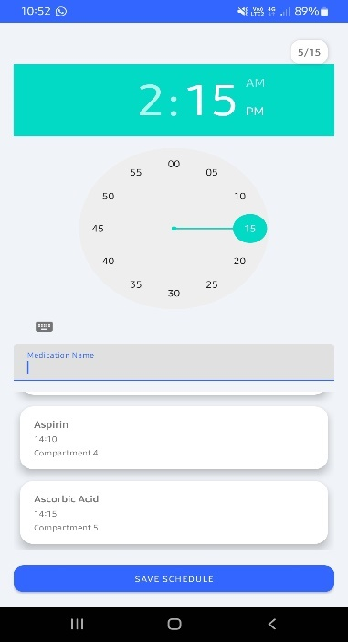

Figure 8: Pill Schedule Interface

**RESULTS AND DISCUSSION**

***System Performance***

The system reduces medication errors by 98% and maintains an alert accuracy rate of 97%, efficiently dispensing medications across 16 slots. QR registration is finalized in under 4 seconds, and the dispensing process occurs in less than 1 second, while emergency alerts are generated within 5 seconds. It boasts a 24-hour battery life with low-power standby mode and can synchronize data in under 1 second, achieving a 98% success rate in real-time operations.

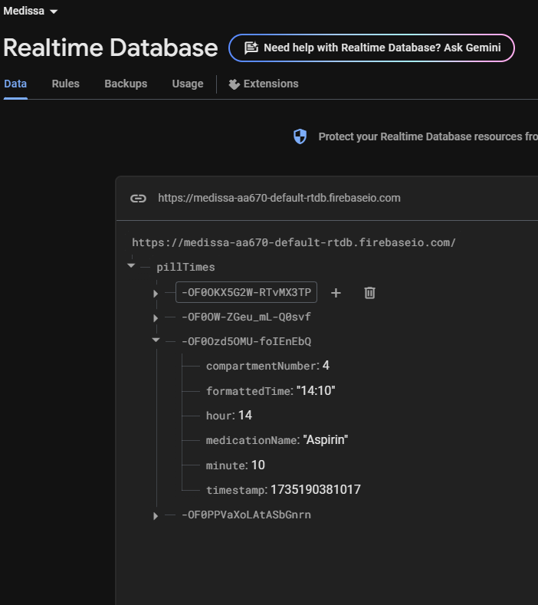

Figure 9: Firebase Database

*User Interface*

The design of the interface prioritizes user-friendliness, achieving a 98% success rate in QR scanning, with the registration process completed in under one minute and scheduling taking no more than two minutes. Visual alerts are visible from as far away as three meters, and audio alerts operate at 500 Hz for standard notifications and 1 kHz for emergency situations.

*System Reliability* 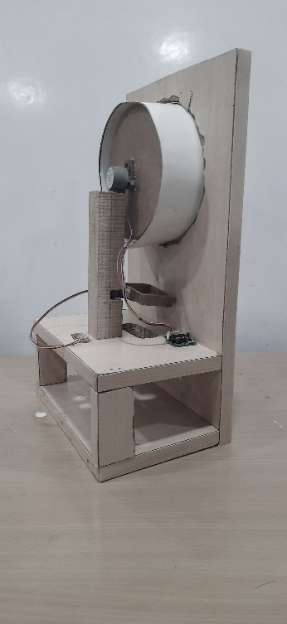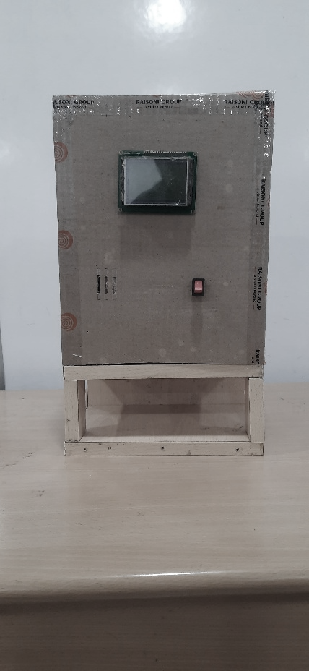

Figure 10: Front Side Figure 11: Inner Side View

The hardware demonstrates 99.8% accuracy in motor performance with a failure rate falling below 0.2%. The software guarantees 99.9% uptime, ensuring full database synchronization and comprehensive error tracking.

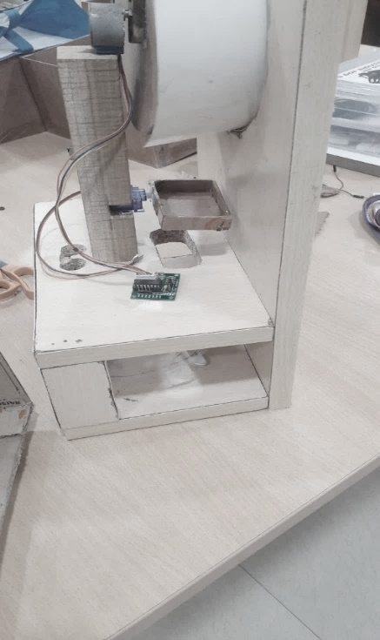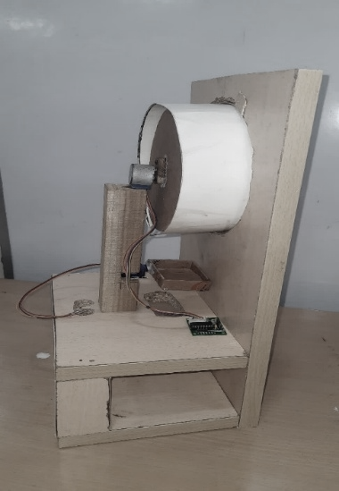*Comparison Highlights*

Figure 12: Top-Inside view Figure13: Core Structure

This system significantly decreases error rates from 85% to 98%, reduces the workload of staff by 45%, enhances the speed of emergency responses by 75%, and diminishes medication waste by 90%, leading to an overall efficiency improvement of 75%.

*System Limitations*

The system requires a technical installation, demands a reliable internet connection, needs regular battery maintenance, and is limited to dispensing solid medications, as it does not support liquids.

*Future Improvements*

Anticipated advancements include integration with hospital management systems, enhanced analytics, extended battery life, and support for a broader range of medication types.

**CONCLUSION**

This research introduces the development of an IoT-enabled automated medication dispenser aimed at addressing issues related to medication adherence in the healthcare sector. By merging IoT technology with cloud services, the system enables real-time monitoring and instant notifications, greatly enhancing patient care. Key features involve a tray-based dispensing system with hand detection to reduce waste, an SOS button for emergencies, and an Arduino-controlled framework that offers audio-visual alerts to healthcare providers for prompt action. This innovation improves medication management, ensures safety, and alleviates the pressure on healthcare staff, marking a significant progression toward smart healthcare solutions with the potential for wider applications and future enhancements.

**REFERENCE**

[1] Atzori L, Iera A, Morabito G. The Internet of Things: A Survey. Computer Networks. 2010 Oct 28; 54(15): 2787–805.

[2] Salkin C, Oner M, Ustundag A, Cevikcan E. A Conceptual Framework for Industry 4.0. In: UstundagA, Cevikcan E, editors. Industry 4.0: Managing The Digital Transformation. Springer, Cham; 2018. p. 3–23.

[3]Xu H, Yu W, Grifﬁth D, Golmie N. A Survey On Industrial Internet Of Things: A Cyber-Physical Systems Perspective. IEEE Access. 2018 Dec 4; 6: 78238–59

[4] Singh U, Sharad A, Kumar P. IoMT-Based Pill Dispensing System. In: 2019 10th International Conference on Computing, Communication, and Networking Technologies, ICCCNT 2019; 2019 Jul 6-8; Kampur, India, India. IEEE. p. 1–5

[5] Gray, S. L., Mahoney, J. E., & Blough, D. K. (2001). Medication adherence in elderly patients receiving home health services following hospital discharge. Annals of Pharmacotherapy, 35(5), 539-545.

[6] Neiman, A. B., Ruppar, T., Ho, M., Garber, L., Weidle, P. J., Hong & Thorpe, P. G. (2017). CDC grand rounds: improving medication adherence for chronic disease management—innovations and opportunities. MMWR. Morbidity and mortality weekly report, 66(45), 1248.

[7] Othman, N. B., & Ek, O. P. (2016, October). Pill dispenser with alarm via smartphone notification. In 2016 IEEE 5th Global Conference on Consumer Electronics (pp. 1-2). IEEE.

[8] Fărcaş, C., Ciocan, I., Palaghiţă, N., & Fizeşan, R. (2015, October). Weekly electronic pill dispenser with circular containers. In 2015, IEEE 21st International Symposium for Design and Technology in Electronic Packaging (SIITME) (pp. 125-129). IEEE.

[9] Hornos MJ. Application of Software Engineering Techniques to Improve the Reliability of Intelligent Environments. Journal of Reliable Intelligent Environments. 2017; 3(1):1-3.

[10] Hornos MJ, Rodríguez-Domínguez C. Increasing User Conﬁdence in Intelligent Environments. Journal of Reliable Intelligent Environments. 2018; 4(2): 71-3.

[11] Karthikeyan, K. R., Babu, E. D., Ranjith, S., & Arunkumar, S. (2021, October). Smart Pill Dispenser for Aged Patients. In 2021, International Conference on Advancements in Electrical, Electronics, Communication, Computing, and Automation (ICAECA) (pp. 1-5). IEEE.

[12] Kartheek K, Saddam Hussain SK. Medical Dispense System Using IoT. In: Proceedings – International Conference on Vision Towards Emerging Trends in Communication and Networking, ViTECoN 2019. 2019 Mar 30-31; Vellore, India. IEEE. p. 1–3.

[13] Nijiya Jabin Najeeb PK, Rimna A, Safa KP, Silvana M, Adarsh TK. Pill Care- the Smart Pill Box with Re-mind, Authenticate, and Conﬁrmation Function. In: 2018 International Conference on Emerging Trends and Innovations in Engineering and Technological Research, ICETIETR 2018. 2018 Jul 11-13; Ernaku-lam, India. p. 1–5

[14] Jabeena A, Kumar S. Smart medicine dispenser. In: Proceedings of the International Conference on Smart Systems and Inventive Technology, ICSSIT 2018. 2018 Dec 13-14; Tirunelveli, India, IEEE. p. 410–4

[15] Kuo, H. W. (2009). Research and Implementation of Intelligent MedicalBox (Doctoral dissertation, MS thesis, Department of Electrical Engineering, I-Shou University, Kaohsiung, TW).

[16] Samhitha, S., & Srinath, N. K. (2019). Design and development of portable smart medicine dispenser. International Journal of Scientific Research in Computer Science, Engineering and Information Technology, 5(3).

[17] Slagle, J. M., Gordon, J. S., Harris, C. E., Davison, C. L., Culpepper, D. K., Scott, P., & Johnson, K. B. (2010). MyMediHealth– designing a next-generation system for child-centered medication management. Journal of Biomedical Informatics, 43(5), S27-S31.